**RAYALA SEEMA**

**UNIVERSITY**

**KURNOOL**

**SRI SANKAR’S DEGREE**

**COLLEGE IN KURNOOL**

***JANGAM VINEETH***

1. ***SC(MSCS)***

***HALL NO : 21364008011***

***PRO JECT BOOK***

***FOR***

***LONG TERM INTERSHIP***

**Name of the Student: JANGAM VINEETH**

**Name of the College: SRI SANKARA ‘S DEGREE COLLEGE**

**Registration Number:21364008011**

**Period of Intership:**

**Name & Address of the intern Organization:**

**An intership Report**

**On**

**(Tital of the intership)**

*Submitted in accordance with the requirement for the degree of B.SC(MSC.S)*

*Name of the college:***SRI SANKARA ‘S DEGREE COLLEGE**

*Department:*

*Name of the Faculty Guide:*

*Duration of the intership :Form ___________To__________*

*Name of the Student:* **JANGAM VINEETH**

*Programme of Study:*

*Year of Study:2021-2024*

*Register Number:21364008011*

*Date of submission:*

**1.Electric vehicle charge & range analysis:-**

Analysing electric vehicle (EV) charging and range involves several factors such as battery capacity, charging infrastructure, charging speed, driving habits, and environmental conditions. Here's a breakdown of each aspect.

* **Battery Capacity:-**

The size of the battery pack determines the vehicle's range. Typically measured in kilowatt-hours (kWh) a higher capacity battery allows for longer driving distances on a single charge. However, larger batteries are usually heavier and more expensive.

* **Charging Infrastructure:-**

The availability and accessibility of charging stations play a significant role in EV adoption, Public charging stations, workplace chargers, and home charging setups contribute to the convenience of EV ownership.

* Charging Speed:-

EV charging speed varies depending on the charging method and the vehicle's compatibility. There are different levels of charging:

* **Level 1 Charging :-**Uses a standard 120-volt household outlet. It's the slowest charging option, typically adding around 2-5 miles of range per hour of charging.
* **Level 2 Charging:-**Requires a 240-volt outlet, commonly found in homes and public charging stations. It provides faster charging, adding around 10-30 miles of range per hour of charging.
* **DC Fast Charging:-**Offers the quickest charging option, capable of adding around 60-80 miles of range in 20-30 minutes, depending on the charger's power and the vehicle's capability.
* **Driving Habits:** Individual driving habits greatly influence an EV's range. Factors such as speed, acceleration, braking, and use of accessories like air conditioning impact energy consumption. Efficient driving practices, such as smooth acceleration and braking, can extend range.
* **Environmental Conditions:** Weather conditions, including temperature, wind, and precipitation, affect an EV's range. Cold temperatures can reduce battery efficiency and decrease range, while hot temperatures can impact battery life. Using climate control systems also affects energy consumption to perform an analysis, you would typically consider these factors together:
* Determine the vehicle's battery capacity and estimate its range under ideal conditions.
* Assess the availability of charging infrastructure along planned routes.
* Calculate charging times based on the charging speed and the desired amount of charge.
* Consider driving habits and environmental conditions to adjust the estimated range accordingly.
* Factor in potential range anxiety and the need for buffer range to accommodate unexpected detours or delays.

Several online tools and calculators are available to assist in estimating EV range and charging needs based on specific models and driving scenarios. Additionally, real-world tests and reviews provide valuable insights into the actual performance of EVs in various condition.

**2. Visualization tool for electric vehicle charge and range analysis:-**

There are several visualization tools available for electric vehicle (EV) charge and range analysis. These tools help users understand and visualize factors such as battery charge levels, driving range, charging station locations, and more. Here are a few examples:

* **A Better Routeplanner (ABRP):-**

ABRP is a popular online tool and mobile app that helps EV drivers plan routes by taking into account factors such as vehicle efficiency, elevation changes, weather conditions, and charging station availability. It provides visualizations of planned routes, including charging stops and estimated charging times.

* **Plug Share:-**

Plug share is a platform and mobile app that maps charging stations worldwide. Users can search for charging stations along their route, view station details, and read user reviews. PlugShare provides visualizations of charging station locations and availability, helping EV drivers plan their charging stops.

* **WattPlan EV:-**

WattPlan EV is an online tool developed by the U.S. Department of Energy's National Renewable Energy Laboratory (NREL). It allows users to analyze the costs and benefits of switching to an electric vehicle, including savings on fuel and maintenance costs. WattPlan EV provides visualizations of estimated fuel savings, greenhouse gas emissions reductions, and payback periods.

* **Tesla Range Calculator:-**

Tesla offers an online range calculator tool on its website, which allows users to estimate the range of Tesla vehicles based on factors such as battery size, driving conditions, and temperature. The tool provides visualizations of estimated range under various scenarios, helping users understand the impact of different factors on their driving range.

* **EV Trip Planner**:-

EV Trip Planner is a web-based tool that helps EV drivers plan long-distance trips by providing information on charging station locations, charging speeds, and driving range. Users can input their vehicle model, starting location, destination, and planned route, and the tool will generate a trip plan with visualizations of charging stops and estimated driving range. These are just a few examples of visualization tools available for electric vehicle charge and range analysis. Depending on your specific needs and preferences, you may find other tools or apps that provide similar functionality.

* **EV VEHICLES AND MODELES :-**

As of my last update in January 2022, there are numerous electric vehicle (EV) models available on the market, offered by various manufacturers worldwide. Here's a list of some popular EV models, but please note that the availability of models may vary depending on your region.

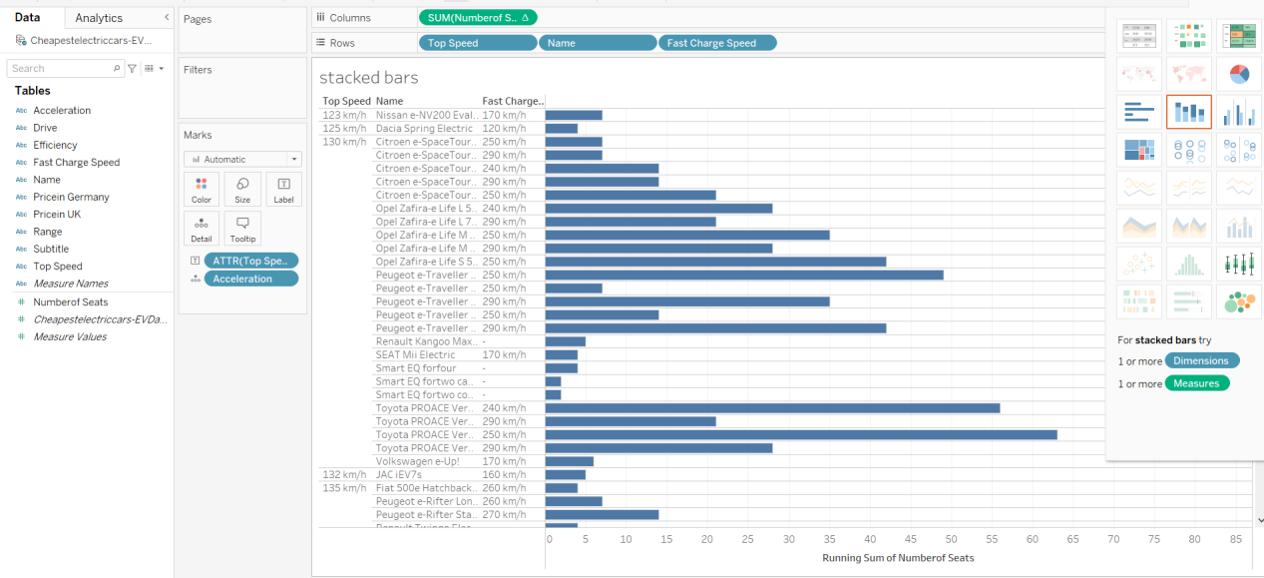

1. **Tesla Model .S :-**

A luxury sedan known for its long-range capabilities, high performance, and advanced technology features.

1. **Tesla Model.3:-**

A more affordable sedan compared to the Model S, offering a balance of range, performance, and interior space.

**3.Tesla Model.X:-**

An SUV with distinctive falcon-wing doors, offering seating for up to seven passengers, long-range capabilities, and advanced features.

1. **Tesla Model.Y:-**

A compact SUV with seating for up to seven passengers, offering similar features to the Model 3 but with additional cargo space and higher ground clearance.

1. **Chevrolet Bolt EV:-**

A compact hatchback offering an affordable price point, respectable range, and practical interior space.



1. **Nissan Leaf:-**

One of the earliest mass-market EVs, offering various trim levels, decent range, and a comfortable driving experience.

1. **Audi e-tron:-**

A luxury SUV available in different configurations, offering premium features, all-wheel drive, and a comfortable interior.

1. **Porsche Taycan:-**

A high-performance electric sports sedan known for its impressive acceleration, handling, and luxurious interior.

1. **Jaguar I-PACE:-**

A luxury SUV with a stylish design, long-range capabilities, and a spacious interior.

1. **Ford Mustang Mach-E:-**

An all-electric SUV inspired by the iconic Mustang, offering multiple trim levels, long-range options, and advanced technology features.

1. **Volkswagen ID.4:-**

A compact SUV with a sleek design, practical interior, and competitive range, representing Volkswagen's entry into the EV market.

1. BMW i3:-

A compact electric hatchback known for its distinctive design, lightweight construction, and agile handling.

**13.Hyundai Kona Electric:-**

A subcompact SUV offering a competitive range, practical interior space, and a comfortable ride.

1. **Kia Niro EV:-**

A compact crossover with a spacious interior, long-range capabilities, and a smooth driving experience.

1. **Rivian R1T / R1S:-**

All-electric pickup truck (R1T) and SUV (R1S) from Rivian, offering impressive off-road capabilities, long-range options, and innovative features.

These are just a selection of electric vehicle models available as of my last update. The EV market continues to evolve rapidly, with new models being introduced and existing models being updated with advancements in technology, range, and performance. It's always a good idea to check with local dealerships or EV manufacturers for the most up-to-date information on available models in your area.



* What different types of charging stations are available :-

The current charging network consists of various types of standardized chargers. They are standardized so that the public charging points are shareable by most EV users. The types of chargers available in the market are AC fast, DC fast, and superchargers. Charging stations are classified according to speeds of charging or type of ownerships namely private and public ownership.

In terms of charging speed characteristics, there are level 1 chargers (household 120 volts), level 2 chargers (240 volts), level 3 and level 4(fast charging types) [8]. Since Emobility is still at infancy, the majority of early adopter’s charge cars at home or at the workplace [7]. For the people who do not have access to charging infrastructure at home or work because they live in apartments, public charging greatly determines electric car usage. The demand for public charging infrastructure increased by up to 60% between 2013 and 2018 [7] and as at the end of 2018, there were already 600,000 public electric car charging points globally.



* I would like to filter by EV connector type:-

I am building an EV charging station map. In my data source, I have the dimension EV Connector Type. Some stations have multiple connectors. In my data source, if a charging station contains multiple connector types, they are listed together (see attached). For example "J1772 TESLA" contains a J1772 plug and a Tesla Plug. I want to make a filter where you can see all the stations that contain one of the connectors. So if I wanted to see all the stations in the USA that have the J1772 plug, the stations that contain J1772 in the string would appear. The only way I could make this work would be to create separate calculated fields for each individual connector type using the CONTAINS function, however this results to be clunky rather than just one filter. Is it possible to create one filter as a single drop down that would show me all the individual connector types.

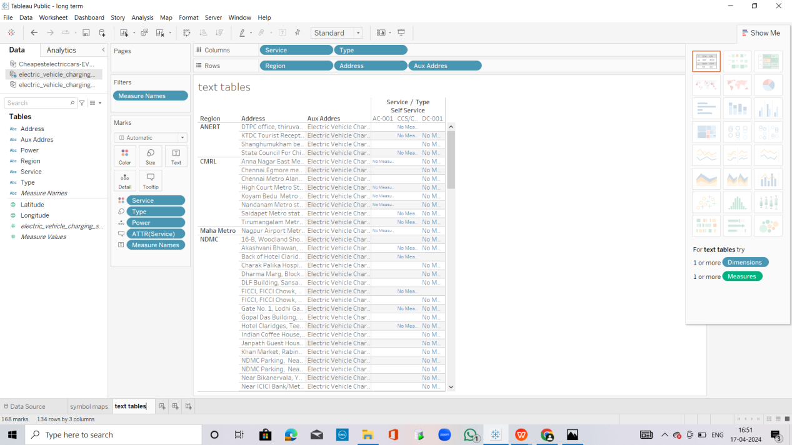

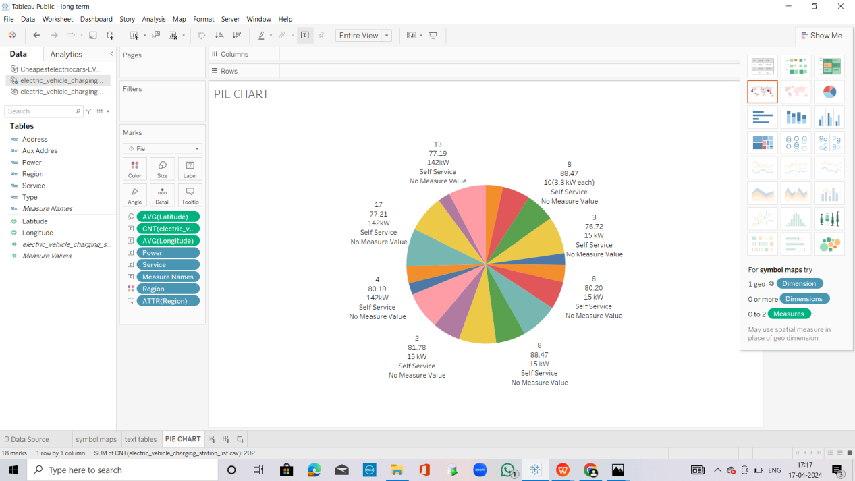

* EV vehicles sructure and companies:-

Electric vehicles (EVs) vary in structure and design, and there are several companies involved in their production. Here's an overview.

* **Structure of Electric Vehicles:-**
* **Battery Pack:-**

EVs are powered by rechargeable battery packs, typically located under the vehicle floor or within dedicated compartments. These battery packs store electrical energy that powers the electric motor(s).

* **Electric Motor(s):-**

Electric motors are used to drive the wheels of EVs. They convert electrical energy from the battery into mechanical energy to propel the vehicle

EVs can have one or more electric motors, depending on the vehicle's design (e.g., rear-wheel drive, front-wheel drive, all-wheel drive).

* **Power Electronics:-**

Power electronics components, such as inverters and converters, control the flow of electrical energy between the battery, electric motor(s), and other vehicle systems. They manage power distribution, motor speed, and regeneration during braking.

* **Charging System:-**

EVs are equipped with onboard charging systems that allow them to be charged from external power sources, such as home chargers or public charging stations. Charging systems include charging ports, onboard chargers, and sometimes DC-DC converters for DC fast charging capability.

* **Vehicle Control Systems:-**

These systems include controllers, sensors, and software that manage various vehicle functions, such as acceleration, braking, steering, and regenerative braking. They also monitor battery health, temperature, and other parameters to optimize performance and efficiency.

* **Body and Interior:-**

The body and interior of EVs can vary widely depending on the vehicle type (e.g., sedan, SUV, truck) and manufacturer. Many EVs feature lightweight materials, aerodynamic designs, and advanced safety and infotainment technologies.

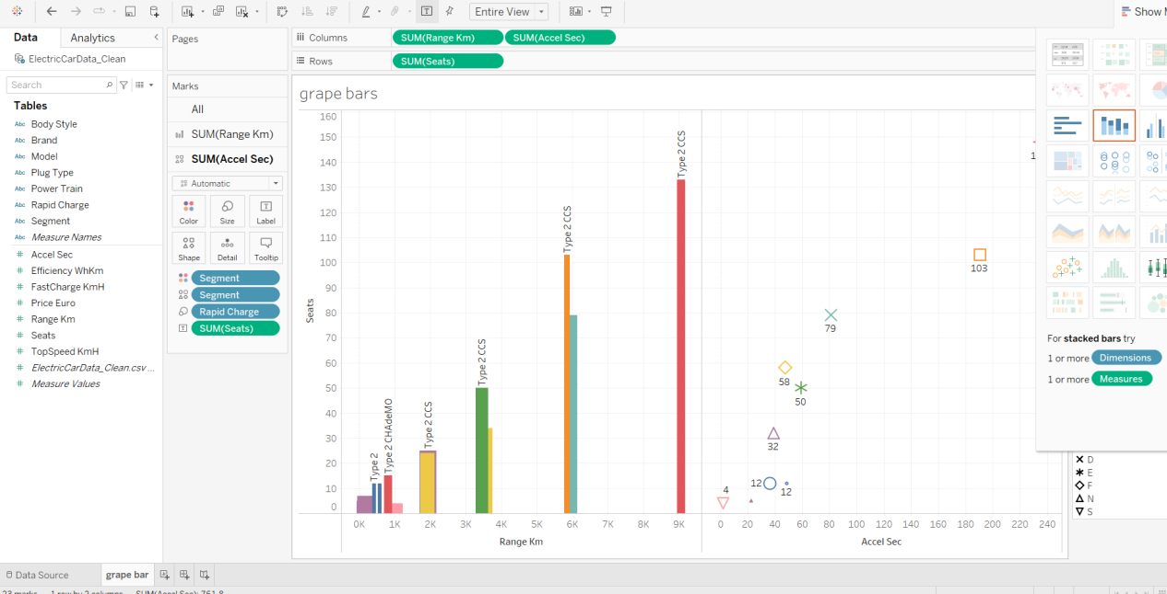

* **Companies Producing Electric Vehicles:-**
* **Tesla :-**

Tesla is one of the most well-known EV manufacturers, producing a range of electric cars including the Model S, Model 3, Model X, and Model Y, as well as electric semi-trucks and the upcoming Cybertruck.

* **General Motors (GM)**:-

GM produces electric vehicles under various brands, including Chevrolet, GMC, and Cadillac. The Chevrolet Bolt EV and upcoming Bolt EUV are among its notable electric offerings.

* **Nissan:-**

Nissan produces the Leaf, one of the world's best-selling electric cars. The Leaf is available in various configurations and has been on the market since 2010.

* **Volkswagen Group:-**

Volkswagen Group is investing heavily in electric mobility through its brands, including Volkswagen, Audi, Porsche, and others. It produces electric vehicles such as the Volkswagen ID.3, ID.4, Audi e-tron, Porsche Taycan, and more.

* **BMW:-**

BMW offers several electric vehicles, including the BMW i3 and iX3, as well as plug-in hybrid models under its "i" sub-brand. It has announced plans to expand its electric vehicle lineup in the coming years.

* **Hyundai Motor Group:-**

Hyundai and its subsidiary Kia offer electric vehicles such as the Hyundai Kona Electric, Hyundai Ioniq Electric, and Kia Soul EV.

* **Rivian:-**

Rivian is an American electric vehicle manufacturer specializing in electric trucks and SUVs. Its R1T pickup truck and R1S SUV are highly anticipated electric vehicles with off-road capabilities.

* **Lucid Motors:-**

Lucid Motors is a luxury electric vehicle manufacturer, producing the Lucid Air sedan. The Lucid Air boasts impressive range, performance, and luxury features.

These are just a few examples of companies involved in producing electric vehicles. Many traditional automakers and startups are investing in electric mobility, driving innovation and competition in the EV market.

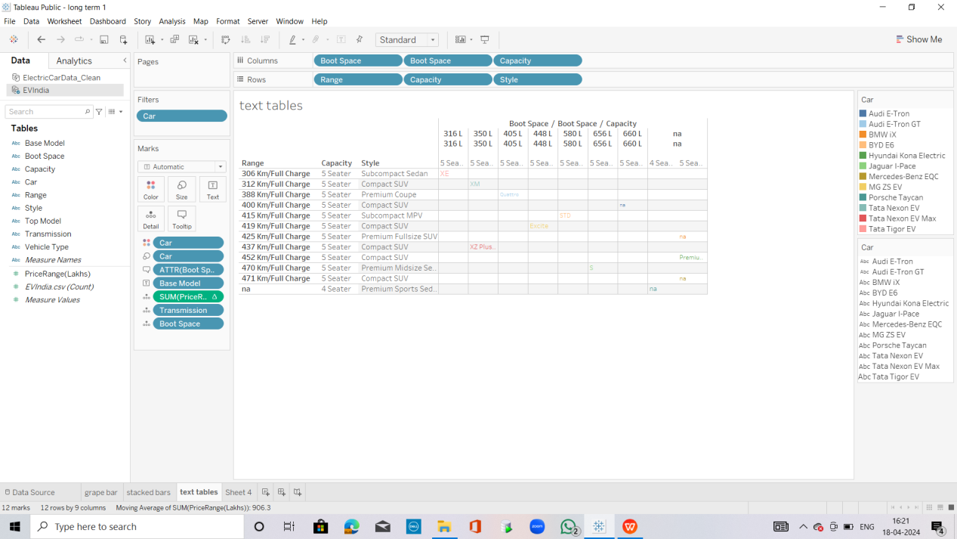

* **EV vehicles how many module tipes are lunched in india:-**

As of my last update in January 2022, several electric vehicle (EV) models have been launched in India across various categories, including hatchbacks, sedans, SUVs, and electric two-wheelers. Here are some of the prominent EV models available in India:

* **Tata Nexon EV:-**

Tata Motors launched the Nexon EV, an electric SUV, which has gained popularity in the Indian market. It offers a decent range, comfortable interior, and competitive pricing.

* **MG ZS EV:-**

MG Motor India introduced the ZS EV, an electric SUV with modern features and a relatively long driving range. It offers a spacious cabin and premium amenities.

* **Hyundai Kona Electric:-**

Hyundai entered the Indian EV market with the Kona Electric, a compact SUV known for its impressive range, performance, and feature-rich interior.

* **Mahindra eVerito:-**

Mahindra Electric, a subsidiary of Mahindra & Mahindra, offers the eVerito, an electric version of its Verito sedan. It provides a practical option for urban commuting.

* **Tata Tigor EV:-**

Tata Motors also offers the Tigor EV, an electric version of its Tigor compact sedan. It targets fleet operators and urban commuters with its affordable pricing and decent range.

* **Ather Energy Scooters:-**

Ather Energy produces electric scooters, including the Ather 450X and Ather 450 Plus, known for their performance, smart features, and connectivity options.

* **Bajaj Chetak Electric:-**

Bajaj Auto reintroduced the iconic Chetak scooter in an electric avatar, offering a blend of retro styling and modern technology.

* **Ola Electric Scooter:-**

Ola Electric, a subsidiary of Ola Cabs, has launched its electric scooter, aiming to provide a cost-effective and eco-friendly mobility solution.

* **TVS iQube Electric:-**

TVS Motor Company offers the iQube Electric scooter, featuring a stylish design, decent performance, and connectivity features.

These are some of the electric vehicle models available in India. The Indian EV market is rapidly growing, with several other automakers and startups planning to launch new models in the coming years. Additionally, the Indian government has been implementing various incentives and policies to promote electric mobility and reduce emissions.



* **Top 10 Electric Vehicle Internship Companies in India**

**Introduction:**

As the demand for **electric vehicles** (EVs) continues to grow in India, there is a need for skilled professionals who can design, develop, and maintain these vehicles. Electric vehicle internships are a great way for students to gain hands-on experience and acquire the necessary skills to succeed in this field. In this blog post, we’ll discuss the top 10 electric vehicle internship companies in India

*Table of Contents :*

1. **Mahindra Electric Mobility Limited (MEML)**
2. **Tata Motors Limited:**
3. **Ashok Leyland:**
4. **Honda Cars India Limited:**
5. **Hero Electric:**
6. **Ather Energy:**
7. **TVS Motor Company:**
8. **Sun Mobility:**
9. **Revolt Motors:**
10. **Ola Electric:**

**1.Mahindra Electric Mobility Limited (MEML):-**



MEML offers internship programs in EV technology that cover topics such as EV design, battery technology, and motor control. The internship is designed for students who want to gain hands-on experience in this field.

**2.Tata Motors Limited:-**

Tata Motors offers internship programs in EV technology that cover topics such as EV design, battery technology, and motor control. The internship is designed for students who want to gain hands-on experience in this field.

**3.Ashok Leyland: -**

Ashok Leyland offers internship programs in EV technology that cover topics such as EV design, battery technology, and motor control. The internship is designed for students who want to gain hands-on experience in this field.

**4.Honda Cars India Limited:-**

Honda Cars India Limited offers internship programs in EV technology that cover topics such as EV design, battery technology, and motor control. The internship is designed for students who want to gain hands-on experience in this field.

**5.Hero Electric:-**

Hero Electric offers internship programs in EV technology that cover topics such as EV design, battery technology, and motor control. The internship is designed for students who want to gain hands-on experience in this field.

**6.Ather Energy:-**

Ather Energy offers internship programs in EV technology that cover topics such as EV design, battery technology, and motor control. The internship is designed for students who want to gain hands-on experience in this field.

**7.TVS Motor Company:-**

TVS Motor Company offers internship programs in EV technology that cover topics such as EV design, battery technology, and motor control. The internship is designed for students who want to gain hands-on experience in this field.

**8.Sun Mobility:-**

Sun Mobility offers internship programs in EV technology that cover topics such as EV design, battery technology, and motor control. The internship is designed for students who want to gain hands-on experience in this field.

**9.Revolt Motors:-**

Revolt Motors offers internship programs in EV technology that cover topics such as EV design, battery technology, and motor control. The internship is designed for students who want to gain hands-on experience in this field.

**Ola Electric**

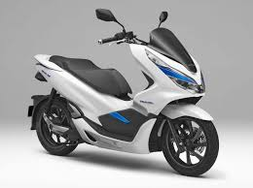

**Ola Electric**offers internship programs in EV technology that cover topics such as EV design, battery technology, and motor control. The internship is designed for students who want to gain hands-on experience in this field.

* **The high cost of electric vehicles**

A third challenge facing Emobility is that the price of electric vehicles tends to be higher than those of conventional cars although this impedes EVacquisition, EV enthusiasts suggest that consumers can be sensitized about the benefits of having such cars such as low.

Data Visualization of the current state of electric mobility infrastructure maintenance costs and the compensatory incentives they get for low pollution.

Additionally, e-mobility faces the problem of parking pressure at the charging spots and this will heighten as more electric cars are purchased.

**E-Mobility**

**1.The number of electric cars worldwide:-**The number of electric cars available on the market as well as the total number registered is one of the main indicators that show the rapid development of Emobility within the last years.

At the beginning of 2019, the number of plug-in electric vehicles increased globally to million including cars and light commercial vehicles with battery-electric drive, range extenders and plug-in hybrids.

The European leader is still Norway, whereas globally China is first and the U.S second While there are a lot of visualizations regarding this topic available, the type of visualization used to showcase the rapid development is almost always a simple line or bar chart regarding the three different types of electric drive vehicles available on the market a more interesting visualization could be found as can be seen in Figure two. Here, the share of each type of the category is compared as well as the share of them in regard to the total vehicle sales in the US.

Data Visualization of the current state of electric mobility infrastructure 17 Visualization of the share of each electric vehicle type within all Evs as well as the percentage of BEVs in regard to the total market.

The latter is an interesting fact which sets the total number of EVs in the context of the switch from fossil fuel cars to electric vehicles.

Even though the growth rate of EV sales compared to the previous years is high Norway is the only country in Europe where people almost prefer purchasing electric vehicles.

Data Visualization of the current state of electric mobility infrastructure 18, EVs as a percentage of total vehicle sales by country/ Markets by total EV sales in 2018 .

To make EVs more attractive to consumers, automakers have to come up with new models in all price ranges. With the number of models growing from less than a hundred in 2019 and more than 300 within the next four years, sales are expected to increase. Especially because Volkswagen announced that its first EV will be cheaper than gasoline cars .

**Conclusion:-**

Electric vehicle internships in India are a great way for students to gain hands-on experience and acquire the necessary skills to succeed in this field. The top 10 electric vehicle internship companies in India discussed in this blog post offer comprehensive internship programs that cover a wide range of topics related to EV design, battery technology, motor control, and charging infrastructure. Enrolling in one of these programs can provide students with the practical experience they need to contribute to the growth of the EV industry in India.

.JANGAM VINEETH

B.SC(MSCS)

21364008011